1. **Purpose/Background:**
   1. Process for running R scripts for analysis of raw clinical and laboratory data
2. **Scope/Applicability:**
   1. Flavivirus data analysis
3. **Definitions:** 
   1. R: a free software environment for statistical computing and graphics. It compiles and runs on a wide variety of UNIX platforms, Windows and MacOS
   2. R studio: a set of integrated tools designed to help you be more productive with R. It includes a console, syntax-highlighting editor that supports direct code execution, and a variety of robust tools for plotting, viewing history, debugging and managing your workspace
4. **Roles/Responsibilities:**
   1. Study staff running reports and creating data tables using flavivirus data
5. **Prerequisites / Supplies Needed**
   1. Data set from CRIMSON or RedCap
   2. R Scripts (stored on Teams)
6. **Procedural Steps**
7. Download R and R Studio for Mac (skip if they are already installed on your computer)
   1. Download R first: go to <https://cran.r-project.org> and click on the R for Mac to download and then select the most recent R package for download.
   2. Download RStudio: go to <https://www.rstudio.com>, click on Download RStudio, and select the Free RStudio for Desktop. (You have to have already downloaded R for this to install properly).
8. Prepare your data files for analysis
   1. Download all .csv files and .r files on to your computer.
      1. R scripts are located in the General Teams folder in the Statistical Programming channel
      2. Open the files section of the channel and locate the folder with the scripts and spreadsheets from the appropriate study
      3. Use the “more options” to open the folder in Sharepoint, then download the entire “Scripts and Spreadsheets” folder to your computer
   2. If analyzing new data files, they must be in .csv format and need to be added to the same folder that contains the corresponding R scripts
   3. Open each .csv file, make sure that there is only ONE row of headers/column names. R will not know how to read it if there is more than one header.
      1. How it should look:

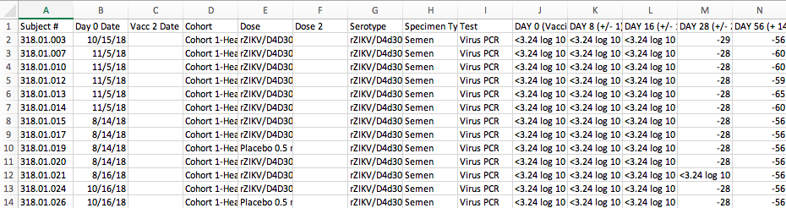

* + 1. How it should NOT look:

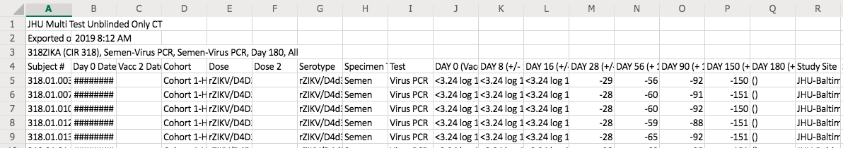

* + 1. If your .csv files do not have the proper headers, change and save it with the same file name in the same place. (Replace the former version)

1. Set up in R studio
   1. Open R Studio.
   2. Set your working directory to the folder with the R script and .csv data files (The Scripts and Spreadsheets folder)
      1. Select Session > Set Working Directory > Choose Working Directory.
   3. Select the .R file which contains the script you will be running
      1. Select File > Open File to open the script you wish to execute
   4. Designate location for output table. (Running the script will create a .csv file with the analyzed data - the following steps set where that file will go and what it will be named)
      1. Go to the console (bottom left panel) type getwd() and push enter to get the path for your working directory. Select and copy this path (not including the quotation marks)



* 1. At the bottom of the script (left upper window), locate the last line of code, which should start with write.csv().
  2. Paste the path you just copied in place of /Users/cirguest/Desktop/ (leave the quotation marks and the forward slash. Whatever is between the forward slash and .csv will be the name of the output file

The syntax is shown here:



Paste working directory path here

Name of output file

* 1. Ensure the Environment (right upper window) is clear (nothing should be in that top right window)
  2. If your environment is not clear, click on the broom in the upper right area of the screen. When it asks to clear all objects, click Yes.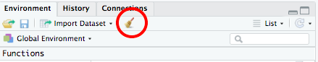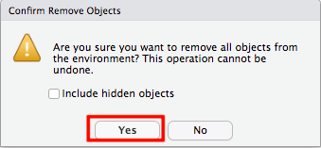

1. Run the Script
   1. Click on the top of the script (which is in the top left window)
   2. Once your cursor is on the top of the script, hold down COMMAND and press ENTER to add all the files and functions to the environment (which is displayed in the bottom left window). Keep holding down COMMAND and pressing ENTER until all of the script has been run.
      1. Note: The method above for running the script is more of a ‘line-by-line' approach. Another way to do it (a little more quickly) would be to click on the bottom line of the script and press command + option + B. This way is more of an ‘all-at-once' approach. While this may be quicker, from the way the script is written, it will always create a .csv file on your computer.
   3. The resulting data table can be viewed in two ways
      1. In the top left window a new tab will have been created which will show the analyzed data
      2. A .csv file containing this table will have been created in the Scripts and Spreadsheets folder. This can be opened in excel and then formatted in word.
2. **Record Management**
3. **Quality Assurance / Quality Control (QA/QC)**
4. **References**